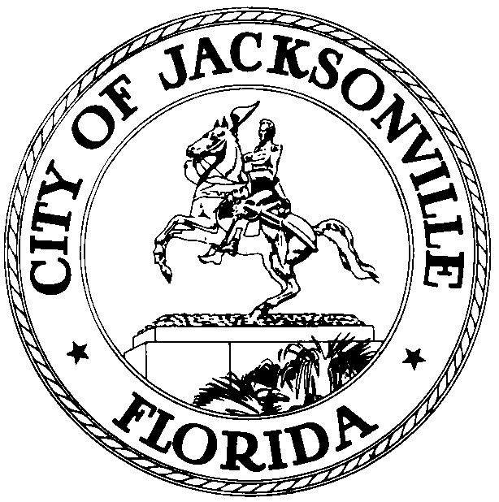

Jacksonville Waterways Commission
Lori Boyer, Chair

JACKSONVILLE WATERWAYS COMMISSION
PRELIMINARY MEETING MINUTES

These minutes are unofficial until reviewed and approved
by the Waterways Commission at a future meeting

June 12, 2019
City Council Chamber
1st floor, City Hall
9:30 a.m.

Attendance: City Council Members Lori Boyer (Chair), Al Ferraro (Vice Chair), Jim Love (Alternate), Jill Haskell, Lindsey Brock, Garrett Barket, Steve Swann, Matt Brockelman, Jed Davis, Steven Davis, Rep. Cord Byrd, Robert Birtalan, Ray Pringle, Marshall Adkinson (ex officio), Bobby Baker (ex officio)
Excused: Steven Davis, Garrett Barket, CM Gulliford
Also in attendance: Dr. Quinton White and Dr. Gerry Pinto – Jacksonville University; Susan Grandin – Office of General Counsel; Jim Suber – Waterways Coordinator; Jessica Matthews, Jessica Smith and Melanie Wilkes– Legislative Services Division; Richard Distel – Council Research Division

Chairwoman Lori Boyer called the meeting to order at 9:31 a.m. and the attendees introduced themselves for the record.

Approval of Minutes
The minutes of the Waterways Commission meeting of May 15, 2019 were approved as distributed. CM Boyer asked if a July meeting would be needed, Mr. Pringle said there a lot of topics needed to discuss and suggested having a July meeting. It was stated by CM Boyer that they would have a July 24th meeting put on the calendar.

Storm Resiliency and Infrastructure Development Review Committee

Bill Killingsworth gave an overview of the Waterways resolution and the technical changes in the legislation - establishing a setback on floodways of 25 feet; established standards for fill material. This resolution will create standards changes for drainage. The changes were posted to the Land Development Procedures Manual. Developers will have to show at each stage how they will manage their storm water and a 6-month inspection period for each development. Requires 100-foot topography around the site, so that oncoming storm water can be caught better. There will be an RFP put out which is focused on infrastructure needs and resiliency to storms. Two new items were brought up at the last meeting of the Committee: investigate and develop goals, objectives and policies to better protect wetlands and identify wetlands as a Land Use category. Secondly, the recommendation that there should be a 25-foot average with a minimum of 15-foot buffer to wetlands that would be consistent with what is currently in the Comprehensive Plan.

Legislation Review
2019-309 (Transmittal Ordinance)
Ed Lukacovic, City Planner, gave an overview of the large-scale land use amendment which would cover almost 2,000 acres. There was a handout given out and Mr. Lukacovic went over the information found in the packet/PDF.

CM Boyer stated that the commission will defer this piece of legislation and not vote on it today and to let the applicant know that the legislation will not be picked up by LUZ until it is approved by the Waterways Commission. CM Boyer told Mr. Lukacovic it would be helpful if the applicant got a conservation easement.

The item was deferred until the next meeting.

2019-362 (Funding Agreement - Dredging)
Teresa Eichner, Capital Improvement Plan Administrator, detailed the matching of funds for the Millers Creek Dredging Project. Mr. Swann asked if this was the normal match for a special district, Ms. Eichner stated this would be the first time doing a match for a special district. CM Ferraro asked how this matching could be used in other Special Districts that need dredging. Ms. Eichner stated that it would just be a partnership with the Mayor’s Administration, and they are open to doing more matching projects.

Resolution 2019-362 was recommended for approval by the Waterways Commission 11-0.

Update: Water Taxi Summary

Jed Davis gave the background on his research into the water taxi service and their importance. Heather Surface, Water Taxi Operator, discussed the service given through education of the waterways and having teachers detail each stop. In 2018 the taxi service purchased a new boat that seats 100 people. Ms. Surface detailed the docks on the St. Johns River and how they have impacted their business. Brian Burket and Bob Skalinsky from the Parks and Recreation Department gave updated information regarding the docks. Jackson Street Dock and Riverplace Dock have gone through the permitting process and currently in the identifying funding phase. The anticipation is to have the funding next fiscal year. This would create an extra dock on the south bank and north bank. The Post Street Dock is still under design, working through design challenges currently. CM Boyer explained that the bulkhead between Hogan and Pearl is being replaced, completely funded in the budget and expected to be started in the next 6 to 9 months. Docks on the north bank that were damaged by the hurricane are still in the permitting process with the federal government and there were delays due to the federal government shutdown. The permit is to replace the dock in front of the landing, repair east end dock and moving all the docks out three feet so there is enough space when the entire bulkhead is replaced. Mr. Adkinson asked about the water taxi trips to the zoo and Ms. Surface stated that if there were available docks at the zoo that would be a trip they would do very often. The water taxi service has 4 boats that can hold up to 360 people. Mr. Burket explained that the zoo docks are currently in the design phase with two potential docking options. Mr. Pringle emphasized the need for access to the waterways and ramp access to water taxis. Mr. Adkinson asked if a temporary dock could be put up at the zoo, because the timetable is approximately two years. Mr. Burket said that is something to look into but he has a concern with the concrete pier that is not in good shape.

St. Johns River Status Report on Water Quality and Manatees

Dr. White said that the city is below average rain fall by 4.5 inches and the water temperature is slightly warmer than the average. Dr. White said that there has been a lot of spotty rain this season. Major algae problems are continuing, due to a lot of nutrients coming from the south. The salinity is back to a normal level.

Dr. Pinto stated that there a third of the normal number of manatees seen in the area currently and are most likely farther south. The current count is 54 manatees. No new mortalities of manatees since last meeting, standing at a total of 2 mortalities.

New Business:

No new business

Old Business:

Susan Grandin, Office of General Counsel, discussed the last meeting which covered the issue of adding signage at Shad Creek. The two ways to add signs in the area would be a boating safety sign or manatee sign. For Shad Creek if a manatee sign would be used it would only be on the river side and the placement would most likely have the boat speeding up right at the bridge and cause more damage. The boating safety sign at Shad Creek would qualify as a “slow speed, minimum wake” sign. This would take an Ordinance being passed by the City Council and an application process through FWC. From the discussion at the last meeting it might be good to not just look at signage for Shad Creek, but all areas that might need these signs. This would allow to do one application with many different areas. Mr. Adkinson talked about the public safety aspect and he supports forming a Committee to look at wake speeds around the City. Mr. Suber talked about the overflow that could happen by opening it up to all areas along the river. There could be a demand that is too much to handle all the requests if opened beyond just Shad Creek. Mr. Suber said he has already received three requests about signs. CM Boyer suggested that Mr. Suber reach out to all the CPACs. Mr. Swann said if we are looking at slow speed zones the Commission should also look at it from the boater’s aspect. CM Ferraro wanted to make sure to focus on the people around Shad Creek, because they have an issue now and currently have damages to their property. He emphasized not slowing down the process to help these people. Ms. Haskell also emphasized that the boaters need to be heard in this discussion. Rep. Byrd talked about the conversations he has had with CM Ferraro regarding Shad Creek and that this is a clear and present problem that needs to be resolved for that community. Ms. Grandin stated that it will have to resolved in an Ordinance and that means it will be in the hands of the new City Council members. The Commission authorized CM Ferraro to work with Susan Grandin and Rep. Byrd on legislation for eligible speed restriction zones along Shad Creek.

Public comment regarding the no wake zones in Shad Creek which was discussed at the last meeting. Residents surrounding the Shad Creek Bridge voiced their worries regarding the speed boats are traveling in the area. Andrew Tully, resident on Shad Creek, talked about the impact and damage to the area and that he was the original complaint about the area. Many other residents of Shad Creek came up to talk about the dangers, damage and impacts in the area.

The vote to put eligible speed regulatory signs on Shad Creek was put to a vote 8-0.

Public Comments: Robert Russo, Chief Trainer at Florida Youth Maritime Training, talked about the work the organization does to give vocational training to at-risk youth. Four-month training and currently training deck engineers. Looking to relocate to Mayport in the near future, currently in Clay County Port.
John Nooney talked about Clay County reef restoration and highlighted the boat launches and the need for better access to the waterways.

There being no further business, the meeting was adjourned at 12:19 p.m.

Minutes: Richard Distel, Council Research
RDistel@coj.net 904-255-5140
7.9.19 Posted 4:30 p.m.
Tapes: Waterways Commission meeting– LSD
6.12.19

